KOMALGABA

FINANCEENTHUSIAST

# PROFILE

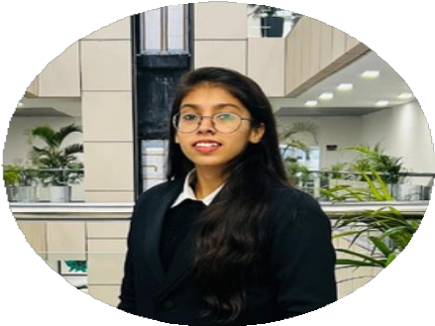

## CONTACT

8813832753

[Komalgaba50@gmail.co](mailto:Komalgaba50@gmail.co)m

[www.linkedin.com/in/k](http://www.linkedin.com/in/k)omal-gaba

Ambalacity,Haryana

## SKILLS

Python Advance Excel TableauPower BI

FinancialAccounting

## LANGUAGE

English Hindi Punjabi

**Driven and result oriented Bachelor of commerce graduate with a strong foundation in Business principles, currently pursuing anMBA in Finance with a specialisation in Fintech .Possess a Keen interest in leveraging technology to innovate and optimizefinancial services .Eager to contribute analytical skills , problem- solving abilities, and a passion for the future of finance to a dynamic organization.**

# EDUCATION

**MBA(Finance)withspecialisationinFintech**

Chitkara University ,Rajpura punjab Expected May 2025**Bachelor of Commerce**

Kurukshetra University,Kurukshetra 2019-2021

# ACHIEVEMENTS

ServedasanactivememberoftheNationalservicescheme(NSS) during my undergraduate studies, organized and lead various community service camps.

Earned Certificates and medals for outstanding contributions to community welfare.

Secured First place in the badminton Tournament held at the college level, competing against teams from various colleges.

Earned a cerificate for actively participating in Global week, a program featuringindustryexpertsfromaroundtheworldatChitkarauniversity.

**PROJECTS**

Presentedacasestudyon**"MbaChaiWala"**

**Actively participated in the Chitkara University Industry Conclave, avaluableopportunitytoengagewithleadingfintechprofessionals.**I had the privilege of networking with industry experts like Ragavan Venkatesan, Avinash Sharan, Pawan Kumar Choudhary, Vikas Dhawan, Debojyoti Dey, and Kamlesh Vora. These interactions provided me with valuable insights into the current fintech landscape and career paths within the industry. The knowledge gained will undoubtedly aid me in enhancing my skills and pursuing a successful career in fintech.